You have already learned the fundamental aspects of Python programming. Now, you are able to create variables of different data types like strings, floats, booleans, lists, dictionaries, and integers. You have also seen that we can use Python to perform different arithmetic operations like addition, subtraction, division, and multiplication. All these concepts are very important because they will help us create our first Python calculator.
For this project, I want us to use a different Python IDE. I believe that you used the Python shell shown below to understand the above concepts.
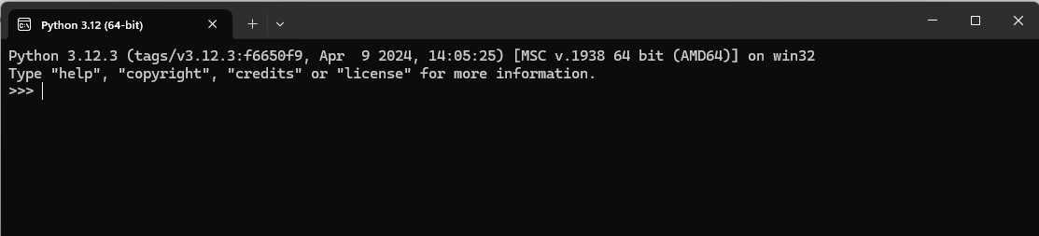
We will be using a more powerful IDE called the visual studio code (VS code) to complete this project.
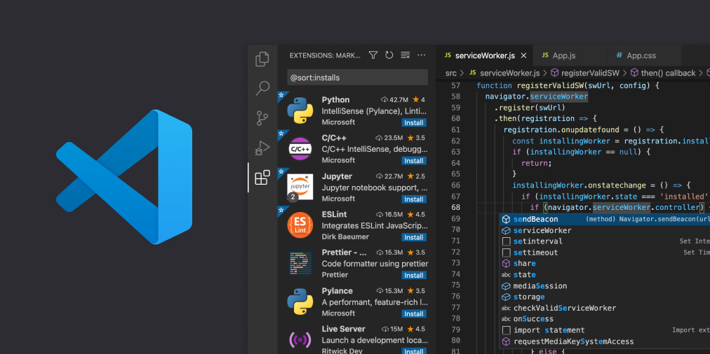But before installing VS code make sure you installed python properly as instructed from the Introduction to Python pdf.

Creating a Python Calculator in VS Code

Step 1: Setting Up VS Code
- Install Visual Studio Code (VS Code)
  - Download and install VS Code from the official website.
- Install Python Extension
  - Open VS Code.
  - Go to the Extensions view by clicking on the square icon in the sidebar or pressing Ctrl+Shift+X.
  - Search for "Python" and install the extension provided by Microsoft.
- Create a New Python File
  - Open VS Code.
  - Click on File > New File or press Ctrl+N.
  - Save the file by clicking File > Save As, and save it with a .py extension, e.g., calculator.py.

Step 2: Writing the Calculator Code
- Open the Python File
  - Open your calculator.py file in VS Code.
- Write the Basic Structure
  - Start by defining the main function and the operations:
def add(x, y):
return x + y
def subtract(x, y):
return x - y
def multiply(x, y):
return x * y
def divide(x, y):
if y != 0:
return x / y
else:
return "Error! Division by zero."
def main():
print("Select operation:")
print("1. Add")
print("2. Subtract")
print("3. Multiply")
print("4. Divide")
choice = input("Enter choice(1/2/3/4): ")
num1 = float(input("Enter first number: "))
num2 = float(input("Enter second number: "))
if choice == '1':
print(f"The result is: {add(num1, num2)}")
elif choice == '2':
print(f"The result is: {subtract(num1, num2)}")
elif choice == '3':
print(f"The result is: {multiply(num1, num2)}")
elif choice == '4':
print(f"The result is: {divide(num1, num2)}")
else:
print("Invalid input")
if __name__ == "__main__":
main()

Step 3: Running the Python Code
- Run the File in VS Code
  - Open the terminal in VS Code by clicking Terminal > New Terminal or pressing `Ctrl+``.
  - Make sure you are in the directory where calculator.py is saved.
  - Run the Python file by typing python calculator.py and pressing Enter.

Step 4: Understanding the Code
- Functions for Operations
  - add(x, y): Adds two numbers.
  - subtract(x, y): Subtracts the second number from the first.
  - multiply(x, y): Multiplies two numbers.
  - divide(x, y): Divides the first number by the second, with a check to prevent division by zero.
- Main Function
  - The main() function displays a menu to the user, takes their choice of operation, and the two numbers to perform the operation on.
- Conditionals
  - The if-elif-else statements check the user’s choice and call the corresponding function.
- Entry Point
  - if __name__ == "__main__": ensures that main() is called when the script is run directly.

Step 5: Enhancing the Calculator (Optional)
- Loop for Continuous Operation
  - Modify the main function to allow the user to perform multiple calculations without restarting the program:
def main():
while True:
print("Select operation:")
print("1. Add")
print("2. Subtract")
print("3. Multiply")
print("4. Divide")
print("5. Exit")
choice = input("Enter choice(1/2/3/4/5): ")
if choice == '5':
print("Exiting...")
break
num1 = float(input("Enter first number: "))
num2 = float(input("Enter second number: "))
if choice == '1':
print(f"The result is: {add(num1, num2)}")
elif choice == '2':
print(f"The result is: {subtract(num1, num2)}")
elif choice == '3':
print(f"The result is: {multiply(num1, num2)}")
elif choice == '4':
print(f"The result is: {divide(num1, num2)}")
else:
print("Invalid input")

Now you have a basic calculator in Python!

